An Epilogue   
  
Eportfolio Rationale: The Value of Creativity in Transformative Learning Approaches

[www.ecologicalcreative.com](http://www.ecologicalcreative.com)

MAIS 700

Jennifer Hakola

December 8, 2023

**Reflection**

Shining a spotlight on our own personal transformative learning throughout the MAIS program and change over the years requires a reflective pause; space to think about how I perceived myself and the world around me in relationship with how I perceive it now. This task demands a kind of inventory process; a search for what’s on board that wasn’t before, and a discovery of what has shifted from its previous position. To begin the process of curating a showcase of my previous works in individual courses with the end goal of having a creative meta-level fabric of all the threads and ideas woven together in a cohesive product required a process by which my integrated learning is evaluated and reviewed in a reflective way. This process began by reviewing each course, reading each assignment and reflecting on forum posts over the last four years. I then selected my favourite most meaningful assignments as artifacts and began a running document containing my initial reflections about these. This led to a collection of 16 artifacts, a 40-page single spaced document of 19,800 words and two new charts to use as maps of the territory. The amount of data generated in this reflective process was a bit overwhelming, but most importantly I had a feeling of not just significance, but that my work in the program held meaning, potential, and gave me a sense of belonging in the world. My attempts to understand other ways of thinking and absorbing new ways of seeing the subjective world through political, social and economic lenses was obvious and looking back I felt a great sense of wonder at the person I was four years ago and my courage to start something new and significant. In order to complete this reflective task, in the last two weeks, I moved my desktop computer out onto the dining room table. It felt like something truly momentous was happening and to prepare for this, it needed to exist in the hub of the home, where all aspects of life meet at the end of the day. In retrospect, this movement of the computer from the office to the dining room was pragmatic and symbolic; it was time for all of my research and ideas to move out of the container and protection of the MAIS program and into the broader world.

**Potential for new discoveries**

My learning journey in the MAIS program at Athabasca University started with the social theory course MAIS 601 where I suddenly realized all of the things I didn’t know. But it was in this course where I caught the bug for venturing into unknown territories of interdisciplinary research. Learning about Jakobson and his work in linguistics with words as symbols for colour, reminded me of how Kandinsky used colour as symbols for emotion. I wondered if they were connected at all in the historical timeline and discovered a world of artistic upheaval during the wars that led to interdisciplinary revolution in the arts. Striking research gold was very seductive and I was hooked on uncovering connections between disciplines in history that had not been studied in specific combinations before.  
 Interdisciplinary study was the catalyst for the artistic upheaval; artists, writers, poets, linguists, dramatists, craftsmen; all worked together in an attempt to create a new mirror through which society saw itself, something to grasp on to in an attempt to feel a momentum and motivation through an abandonment of the past traditional values that no longer provided people a sense of security. Both men strove to find the essence of their respective fields; the smallest threads of truth that were found at the heart of all ventures in art and language. Both men shared an understanding of their place and significance in time. Interestingly, they both rejected Dadaism; Kandinsky for its disrespect of the future and Jakobson for its disregard of the past. They both learned from the past by building upon the theories that had come before them and worked to carve out a creative space in society for those theorists of art and language that would come after them by writing extensively on their findings and new discoveries. There was a strong Theosophical influence emerging during this time and it was inspiring a search for hidden and universal truths. This notion of discovering the essential elements and truth behind life, spread across disciplines and acted as a bridge between them, particularly in the arts. I was able to connect Kandinsky and Jakobson to one degree of separation with Mme Blavatsky and Theosophy, and Malevich through Russian theatre as well as more general symbolist influences at the time, including the study of hearing colours as sounds.   
 In a time of great turmoil, experimentation in the arts was the method of discovery artists and writers were using in an interdisciplinary approach to their work. They turned to their contemporaries in science, religion, anthropology, language, art and music in an attempt to find the true essence of being and thus the spiritual point behind all life. There were no limits to what they could turn to for inspiration and use to inform their own disciplines. For Kandinsky and Jakobson, critical analysis of their work was both self-reflective and self-motivating. With each new idea, a previously undiscovered layer was revealed. They both sought to find the structure and smallest matter within their work and they did this while recording it all in writing. In breaking with traditional ways of learning, both men carved out new ways forward for the future. When global crisis was happening around them, they turned to their contemporaries and to their own inner being in search of small kernels of universal truth upon which to offer the people a new knowledge and hope for a secure foothold.  
 Kandinsky and Jakobson became interdisciplinary role models that stuck with me through the 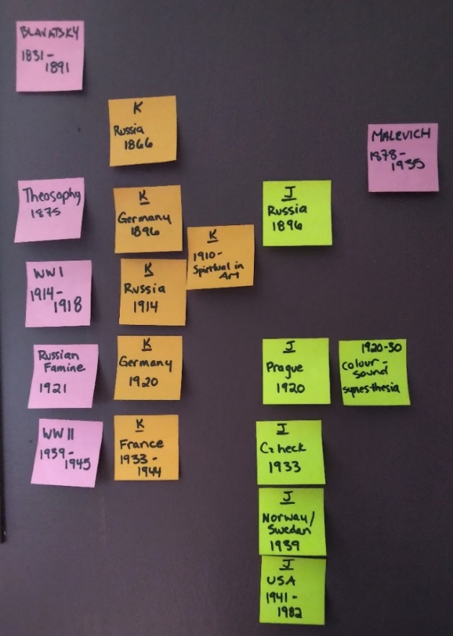next four years of study in the program. I wasn’t able to uncover the imagined moment they were sitting on a train together, or rubbing elbows at a conference, but I was able to get pretty close. As with most research projects in the MAIS courses, I felt like I could explore the study for years and continue to uncover more significant connections to benefit of us now.   
 Here is a picture of the growing collection of sticky papers on my wall at the time as I ventured further and further into the past to find when and where they could have overlapped.

**Self-formation and transformation**

The most obvious elements of transformation have been changes to my perspective on where I am situated within the economic and political frame of capitalism currently in my career and age. The shift is perhaps subtle, but now I perceive some organizations, such as non-profits and social service agencies in terms of having socialist values trapped within a capitalist container that will slowly suffocate and erode the socialist perspective. I recognize now there is an economic spectrum of socialism on the one side and capitalism on the other upon which organizations can exist anywhere, but over time they will either collapse or continue towards capitalism. To be in existence, is to be in relationship with money. Even in resistance and rejection to this economy, people are still by its very nature, in relationship with it and ultimately capitalism. For every non-profit that has employees that feel they are self-sacrificing and working for the good of the people, there is a larger capitalist container profiting from this good-neighbour mentality and allowing those employees to believe what they are doing is necessary to ensure the care of marginalized and vulnerable people. In reality, this is a socialist attitude trying to exist in a capitalist economy which, at this time, cannot succeed without giving in to capitalist motivations. Somewhere the money is being made and if it isn’t by the organization, then its by someone else based on their labour. The larger capitalist organizations could be paying their profits toward supporting the vulnerable in our communities, but then that would not be capitalism.   
 Creative social sector workers, educators, learners, even artists all find themselves in a tension with this capitalist framework that seems it will go on forever, but this would require capitalism to have existed comparably into the past as well and it did not. There are and were alternatives to the two economic forces, some of which seem like a societal death wish, others seem possible but extreme in many ways. There was something before capitalism, something before socialism, something before economies and political structures. But what was that? Mere survival? Through the study of Marx, Weber, Durkheim and Horkheimer, I learned how to cast a critical eye toward how our society was functioning in relationship to production, capitalism, economy and ultimately power. This broadened my view regarding protecting ecosystems and respecting the non-humans that live in them. While in the MAIS program, I have been witnessing the global society starting to experience shared crises again; unstable economies, political upheaval, social divisions, climate change, pandemic, and unbelievably even war.   
 Having a capitalist tension within education is also a new understanding to me. I was interested in learning about how specialized minds who have spent their lifetime honing a craft, trade, or subject matter, now are needing to commodify their life’s knowledge into saleable parts or units from which they are disconnected from the outcome. It seems that our time during the pandemic has made this more pronounced and acceptable. For example, online learning is now expected in everything. Whether its cooking, yoga, financial planning, or traditional subjects, learning is expected to have delivery options, one of which is to purchase access to a unit, consume it on your own time, in your own home, without interaction if you so choose. Previously our work-life was intertwined with our social lives, but this is not a given paradigm anymore. Now, not only has capitalism insisted on turning everything, including one’s creativity and ideas into saleable and repeatable units, it has also, surprisingly, continued to benefit through the isolation of the worker and consumer. Capitalism requires workers to be disconnected from the final product and this has long been encroaching into education delivery. Ultimately, I have learned many new ideas that have created transformation in my perspectives about myself and my relationship with the world.   
 I also learned from Brookfield, Mezirow, Gramsci, Freire and Foucault gaining an interest in social responsibility, developmental aspects of becoming a human within a constructed culture and transformational shifts of becoming fully adult. They assume knowledge, beliefs and values are connected in true transformational change and adult learning through ideology critique approaches. The creation of critical social theory has to not only critique the current social frameworks but also must offer a new way of being and seeing. The real question I am left with is, how will people unite around social change if no one agrees with each other.   
 I have included in my eportfolio a timeline that maps current events that were influential during my time in the MAIS program shown with the courses I was taking at the time. This process of creating this timeline has reflected to me just how much the influences in my life were then reflected in the topics I explored and how the courses were informing my experiences in life.   
 **Integrated Learning**

The readings from the transformative learning, anthropology, and education courses integrated together in a way that allowed me to research topics in an interdisciplinary way beyond what was offered in the course. I could incorporate other topics that I was interested in and research them through the framework I was learning about in the class.  
 Prior to starting the MAIS program, my background was in fine arts and art therapy. As an artist, my praxis has been encouraging others to engage in art making as reflective practice for social change. This was further developed through professional training to be an art therapist and working with participants in community with the aim of bringing about well-being and personal growth. Shifting slightly to working within a training program as an instructor, supervisor and research advisor, has led me to understand the importance of learning from within through experiential learning and reflection through arts-based approaches. My favourite courses to teach have been those that explore the theory behind what is actually happening during the art therapy process which is often framed through psychology theory, Indigenous relational approaches to well-being, and experiential clinical practice.   
 During my career I have been fortunate to be part of the process of writing and securing grants to bring art making studio experience to marginalized people in my community. It was very inspiring to see how the community responded to these opportunities. Many parties were involved; art therapists, mental health clinicians, street outreach, advocacy workers, people living on the street, and families suffering poverty of a variety of backgrounds, experiences and cultures. It was my intention to learn more about the theory behind how to build healthy relationships in community through art making and participation to better inform my ability to advocate for such projects.   
 Another area of interest that has become more embodied and empowered through my studies is the notion of arts-based learning. While I have always practiced this in my teaching and advocated for this as a valuable learning approach, I now have the theory and language to back this approach up and inform dialogue surrounding this. Through the education courses I was able to explore how creativity can blend with other educational approaches and trace the importance of art through the Canadian history of education. In learning more about Indigenous approaches to knowing, I am more committed to the idea that arts-based learning can be the bridge between diverse cultures learning within a common space while avoiding the negative aspects of “including” others within the current dominant system of education. Arts-based learning can create a common ground where all voices can be shared and understood through experiencing creative ways of learning together and about each other. I have also gained a greater appreciation for research that includes film to capture the true voices of people and not only a written transcript of what was said.   
 These areas of interest have opened up new streams of thinking and inspiration for me because of the interdisciplinary ability to invite many perspectives and ways of looking at one specific situation to inform the current dialogue, and also to further the path to solutions. Using creativity intentionally with transformative learning can offer opportunity to find solutions to division and inequities. This is accomplished by eliminating social barriers through sharing cultural perspectives by expressing our interdependence within relationships. Ultimately, through the MAIS program, I was able to create an interdisciplinary list of the values of creativity in transformative learning that I will take with me as a compass to navigate ways to transform education, address social injustice, and protect ecosystems and those that live there. This list of values is: (1) Building relationships and understanding interdependence, (2) Eliminating social barriers, (3) Transformative power of image, and (4) Sharing perspectives through expression.  
 Here is a map depicting the overall organization of the eportfolio with the intention of showing which disciplines and areas of interest will be included and how they will be showcased in their interdisciplinary relationships. The overarching theme will be transformative learning. The value of transformation of our ways of being and thinking will be highlighted through the disciplines of education, research and anthropology as a way forward through the current social and global challenges that simultaneously divide and unite us. An addition to this map is two blue arrows. I have come to understand that the links between arts-based learning in education, Indigenous approaches to research, and a post humanism lens is the interdisciplinary area that I have most enjoyed and feel the most empowered to create ripples of change in the world.

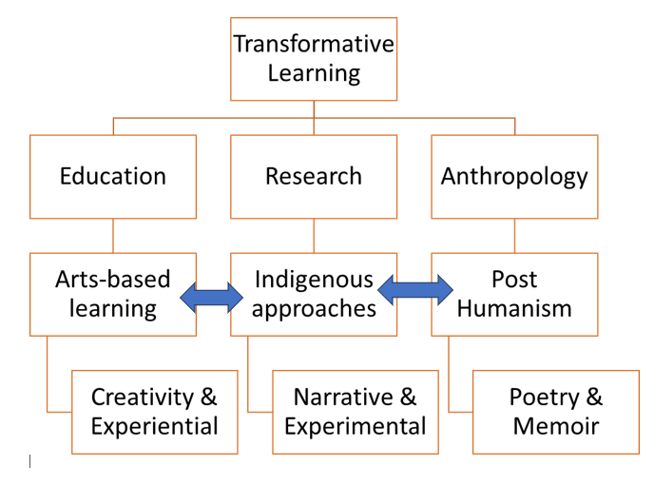

**Social relevance**

While teaching art therapy during my MAIS studies I was able to incorporate my new learned perspectives on post humanism, experiential learning, transformative learning, and history of education. This allowed me to have meta-dialogue with students about how and why we were learning the way we were and not only about the course content. I am hopeful that this has supported the learners in their training and also in their careers when faced with new challenges. My time in the MAIS program has also coincided with a shift in the arena of therapy from a hierarchical relationship between therapists and clients to a more lateral, or side-by-side relationship based on a shared experience of co-creation and allyship. The courses on Indigenous Studies, Research Methods and Anthropology have informed my process of dialoguing with students about how this shift is happening and addressing their feelings of uncertainty regarding their place in the changing tides.   
            Some areas I would like to investigate further are the ones that I feel are already building momentum from my time learning in the program. Topics I am interested in exploring are found where education, Indigenous research and ways of learning, art, creativity and post humanism intersect. By using these disciplines to look at the value of arts-based learning in schools in Canada as a bridge between diverse cultural understandings without any one culture being assimilated or less represented. A multidisciplinary approach could be used for this by examining the topic from many perspectives. An interdisciplinary approach could also be used to further look at the topic by using one discipline to explore another such as using Indigenous research methods to discover the role creativity could play in schools, or using a historical research approach to learn how arts-based teaching can bridge social divides.    
          I would also like to further explore our relationships with specific animals and landscapes through a post humanistic approach to understanding the possible sites where changes can occur. These explorations would include the disciplines of economics, politics, history, anthropology and philosophy. This exploration could be done with a transdisciplinary approach by using the many disciplines to discover solutions beyond any one discipline.

**Conclusion**

Over the past four years I have learned a great deal about myself, others, and the world we live in. I have more of a sense of the collective shared experience of living on earth and the complexity of that paradigm. It could be easy to give up in the face of global challenges, to look the other way and spare ourselves the agony of witnessing the suffering, but this program has encouraged me in a foundational way that ideas can start with just one person, theory can be developed, minds can be changed, groups can come together and accomplish tremendous upheavals. This type of heavy lifting is not beyond us if we work together to bring understanding and peace to areas of destruction and injustice. The MAIS program has shown me this through the thousands of meaningful readings that were thoughtfully handpicked and insightful perspectives of all the instructors along the way.

Thank you,

Jen Hakola   
December 7, 2023

Eportfolio:

[www.ecologicalcreative.com](http://www.ecologicalcreative.com)